PROJECT REPORT: NETWORK ANOMALY DETECTION USING MACHINE LEARNING

DEPARTMENT OF CYBER FORENSICS AND INFORMATION SECURITY (CFIS)

NAME: PURBASHA SANTRA
SEMESTER: 5TH
REGISTRATION NO.: D222303474
SESSION: 2025-26

Under the guidance of: Dr. Partha Sarathi Goswami
Lecturer in Computer Science and Technology
Secretary, Academic Council
Behala Government Polytechnic

Department of Cyber Forensics and Information Security
Behala Government Polytechnic
(Affiliated to West Bengal State Council of Technical & Vocational Education & Skill Development, Government of West Bengal)
756, U. N. Banerjee Road, Parnasree, Kolkata-700060

CERTIFICATE OF APPROVAL

This is to certify that the project report entitled "Network Anomaly Detection Pipeline using Machine Learning" is a bona fide record of the work carried out by the following students of the Department of Cyber Forensics and Information Security (CFIS):
- SUBHRAJIT GHORAI
- JULEE MAHATO
- PURBASHA SANTRA
This project has been completed in partial fulfillment of the requirements for the award of the Diploma in Engineering (5th Semester) under the West Bengal State Council of Technical & Vocational Education & Skill Development (WBSCTVESD). To the best of my knowledge, the results embodied in this report, are original in nature and worthy of incorporation in the present version of the report for Diploma programme in Cyber Forensics and Information Security of Behala Government Polytechnic in the session 2025-26.
It is understood that by this approval the undersigned does not necessarily endorse or approve any statement made, opinion expressed or conclusion drawn therein, but approve this project report for the purpose for which it is submitted.

______________________________  Dr. Partha Sarathi Goswami  Project Supervisor  Department of Cyber Forensics and Information Security  Behala Government Polytechnic | ______________________________  Dr. Sudipta Kr Ghosal  Head of the Department  Department of Cyber Forensics and Information Security  Behala Government Polytechnic
______________________________  Dr. Partha Sarathi Goswami  Secretary, Academic Council  Behala Government Polytechnic | ______________________________  Sri. Narendra Nath Sinha  Principal-in-Charge  Behala Government Polytechnic
ACKNOWLEDGMENT

We express our sincere gratitude to Sayuj Sur, our esteemed Mentor and Project Co-ordinator, for his invaluable guidance, constant motivation, and the technical insights provided throughout the development of this project. His mentorship was instrumental in shaping the architecture of our machine learning pipeline.
We are deeply indebted to Dr. Partha Sarathi Goswami, Lecturer in Computer Science and Technology and Secretary, Academic Council, for his visionary leadership and for providing the necessary administrative and academic support within the Department of Cyber Forensics and Information Security (CFIS).
Finally, we would like to thank our parents. Without their love, patience and support, we would be unable to complete this project.

Project Contributors
Name | Registration Number | Role
SUBHRAJIT GHORAI | D232404829 | Lead Developer & ML Architecture
JULEE MAHATO | D232404832 | Data Handler & Pre-processing
PURBASHA SANTRA | D222303474 | Documentation & Model Evaluation

Date:

TABLE OF CONTENTS
SL NO. | CHAPTER / TOPIC | PAGE NO.
 | CERTIFICATE OF APPROVAL | 1
 | ACKNOWLEDGMENT | 2
 | ABSTRACT | 4
1 | INTRODUCTION | 5
2 | LITERATURE SURVEY | 6
3 | SYSTEM ARCHITECTURE | 7-11
4 | METHODS AND LIBRARIES USED | 11-13
5 | TECHNICAL IMPLEMENTATION | 13-16
6 | RESULTS AND DISCUSSION | 16-19
7 | CONCLUSION AND FUTURE SCOPE | 20-21
8 | REFERENCES | 21

ABSTRACT
As the complexity of cyber-attacks evolves beyond the capabilities of traditional signature-based security systems, the need for intelligent, behavioral-based detection has become paramount. This project, titled "Network Anomaly Detection Pipeline using Machine Learning," presents a robust end-to-end framework designed to identify and classify network intrusions with high precision. Utilizing the benchmark KDD (Knowledge Discovery and Data Mining) dataset, the research explores the efficacy of three distinct computational paradigms: Ensemble Learning (Random Forest), Deep Learning (Multi-Layer Perceptron), and Unsupervised Outlier Detection (Isolation Forest).
The proposed pipeline implements a rigorous data-handling methodology, including string-level label cleaning, binarization of attack vectors, and high-dimensional feature transformation through One-Hot Encoding. To ensure statistical validity, the models were evaluated using a stratified 80/20 train-test split, focusing on critical performance metrics such as Accuracy, F1-Score, and AUC (Area Under Curve).
Experimental results demonstrate a clear hierarchy in performance: the Random Forest model emerged as the superior classifier, achieving an accuracy of 1.00 and a perfect F1-score, indicating that the tree-based ensemble approach is exceptionally well-suited for the structural characteristics of network traffic data. The Keras MLP also showed strong predictive power (0.93 Accuracy), while the Isolation Forest provided a viable unsupervised alternative for identifying zero-day threats without labeled training data. This study concludes that an integrated machine learning approach significantly enhances the proactive defense posture of network infrastructures, offering a scalable solution for modern Cyber Forensics and Information Security applications.
Keywords: Machine Learning, Network Intrusion Detection, Cyber Forensics, Random Forest, Deep Learning, KDD Dataset, Anomaly Detection.

1 INTRODUCTION

1.1 Background
In the modern era of ubiquitous connectivity, network security has emerged as the cornerstone of digital infrastructure. As organizations migrate to cloud-based services and distributed architectures, the volume and complexity of network traffic have increased exponentially. Traditional security perimeters, once defined by simple firewalls and static rules, are no longer sufficient to protect against the sophisticated landscape of modern cyber threats.
Network anomalies—defined as patterns of activity that deviate significantly from established normal behavior—often serve as the first indicator of a security breach. These anomalies can range from Denial of Service (DoS) attacks, which aim to exhaust system resources, to more insidious "Probe" attacks designed to map out network vulnerabilities for future exploitation.

1.2 Problem Statement
Conventional Intrusion Detection Systems (IDS) primarily rely on signature-based detection. This method compares network traffic against a database of known attack "signatures." While effective against previously documented threats, this approach suffers from two critical flaws:
Zero-Day Vulnerabilities: It cannot detect new, undocumented attacks for which a signature does not yet exist.
Polymorphic Threats: Sophisticated attackers can slightly alter the code or behavior of an attack to bypass static signature checks.
There is a critical need for an intelligent system that focuses on Behavioral Analysis rather than static pattern matching. By utilizing Machine Learning (ML), we can train systems to understand the statistical properties of "Normal" traffic and flag anything that deviates from those norms as a potential intrusion.

1.3 Project Objectives
The primary goal of this project is to design and implement a comprehensive Machine Learning pipeline for Network Anomaly Detection. The specific objectives include:
Developing a robust preprocessing engine to handle high-dimensional network data.
Implementing a comparative analysis between Supervised Learning (Random Forest, MLP) and Unsupervised Learning (Isolation Forest).
Evaluating model performance using Cyber Forensics metrics like Accuracy, F1-Score, and AUC.
Identifying key network features that are most indicative of malicious activity through feature importance analysis.

2 LITERATURE SURVEY
2.1 Evolution of Intrusion Detection Systems (IDS)
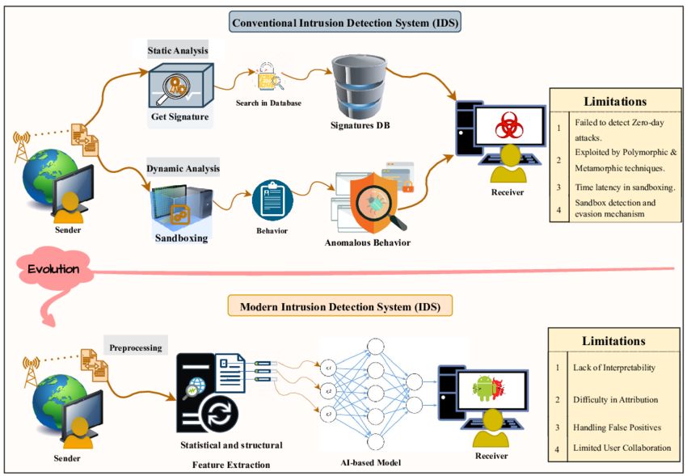
The concept of intrusion detection was first formalized by James Anderson in 1980, who suggested that audit trails could be used to identify misuse. Later, Denning (1987) proposed the first model for a real-time IDS based on statistical anomalies. Early systems were predominantly rule-based, but as network protocols became more complex, the research community shifted toward Artificial Intelligence.
2.2 The KDD Cup 99 Dataset: A Benchmark
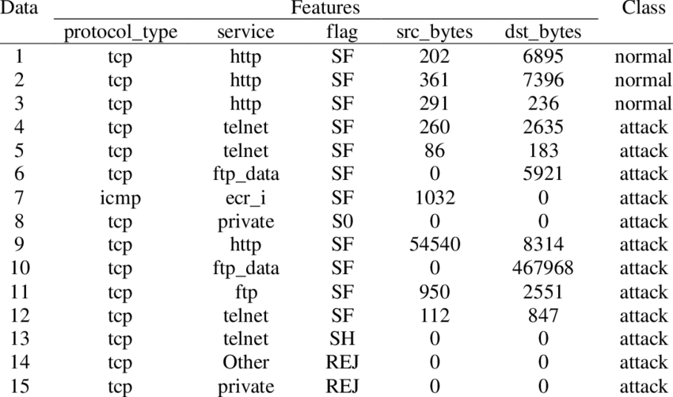
The KDD Cup 99 dataset remains the most widely used benchmark for evaluating anomaly detection algorithms. It was derived from the 1998 DARPA Intrusion Detection Evaluation Program conducted by MIT Lincoln Labs. Researchers like Tavallaee et al. (2009) have analyzed the dataset extensively, noting that while it has limitations (such as redundant records), it provides a rich feature set of 41 attributes—including basic TCP connection features, content features, and traffic features—that are essential for training behavioral models.

2.3 Comparative Studies in Machine Learning Paradigms
Extensive research has been conducted on the performance of different ML algorithms in the cyber domain:
Ensemble Methods: Breiman (2001) introduced the Random Forest algorithm, which has consistently proven to be one of the most effective tools for network classification due to its ability to handle non-linear relationships and provide feature importance rankings.
Neural Networks: With the advent of Deep Learning, Multi-Layer Perceptrons (MLP) have been used to capture complex, high-level abstractions in packet data. Research suggests that while MLPs require more computational power, they are highly effective at generalizing patterns in large datasets.
Unsupervised Learning: Liu et al. (2008) proposed the Isolation Forest specifically for anomaly detection. Unlike traditional methods that build a profile of "normal" data, Isolation Forest isolates anomalies based on the fact that they are "few and different," making it a powerful tool for detecting previously unseen (Zero-Day) attacks.

2.4 Gap Analysis
While many studies focus solely on achieving high accuracy, there is a gap in research regarding the Explainability of these models in a Cyber Forensics context. This project aims to bridge that gap by not only predicting anomalies but also providing visual evidence through feature importance plots and confusion matrices, enabling security analysts to understand why a specific connection was flagged as a threat.

3 SYSTEM ARCHITECTURE
The architecture of the Network Anomaly Detection Pipeline is designed as a modular, four-layer framework. This modularity ensures that each component—from raw data ingestion to final model evaluation—can be independently optimized or scaled. The system follows a "Batch Processing" paradigm, where historical network logs are transformed into actionable security intelligence.
3.1 Architectural Workflow Diagram (Conceptual)
The data flows through the following stages:
- Data Layer: Raw KDD Ingestion.
- Preprocessing Layer: Data Cleaning & Transformation.
- Intelligence Layer: Model Training (RF, MLP, Isolation Forest).
- Evaluation Layer: Performance Metrics & Visualization.
3.2 Data Ingestion Layer
The foundation of the architecture is the Data Ingestion Layer, managed by data_handler.py.
- Input Source: The KDD dataset containing 41 features per connection record.
- Component: load_data() function.
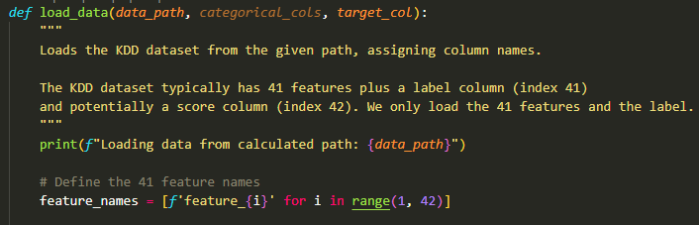
- Logic: The system maps the raw CSV structure to a structured Pandas DataFrame, assigning logical feature names (feature_1 to feature_41) and isolating the ground-truth labels for supervised training.
3.3 Data Preprocessing & Feature Engineering Layer
This is the most critical layer for ensuring model accuracy. It transforms human-readable logs into a mathematical format suitable for machine learning algorithms.
- Label Sanitization: Uses string manipulation to strip trailing periods and whitespace from attack labels, ensuring consistent binarization.
- Target Binarization: Converts multi-class attack names into a binary format:
  - 0 (Normal): Regular network traffic.
  - 1 (Anomaly): Malicious activity (DoS, Probe, R2L, U2R).
- One-Hot Encoding (OHE): Categorical features such as protocol_type, service, and flag are expanded into numerical binary vectors. This prevents the model from assuming a mathematical hierarchy between different services (e.g., HTTP vs. FTP).
- Data Stratification: Employs a stratified split (80/20) to ensure the test set accurately represents the imbalance ratio found in the original network traffic.
3.4 Model Intelligence Layer
The Intelligence Layer hosts the core logic for the three computational models:
3.4.1 Supervised Random Forest
- Architecture: An ensemble of 100 decision trees.
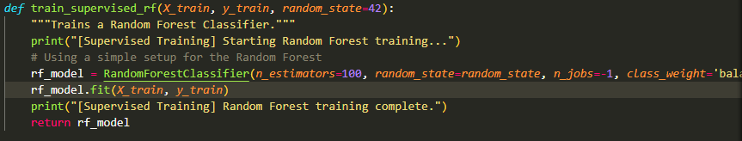
- Integration: Utilizes class_weight='balanced' to ensure that minority attack classes are given equal priority during the learning phase.

3.4.2 Supervised Multi-Layer Perceptron (MLP)
- Architecture: A deep learning sequential model built on TensorFlow.
  - Input Layer: Matches the dimensionality of encoded features.
  - Hidden Layers: Two dense layers (64 and 32 neurons) with ReLU activation for non-linear pattern recognition.
  - Regularization: A Dropout layer (0.2) to prevent overfitting.
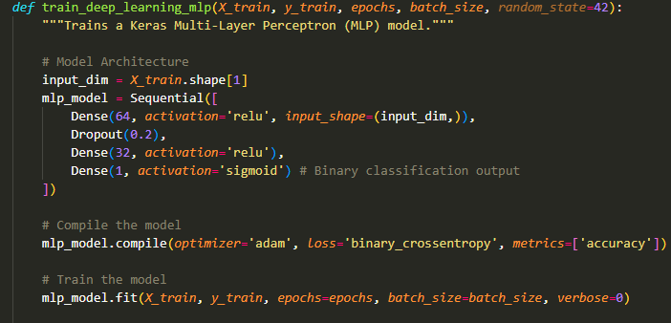
  - Output Layer: A single Sigmoid neuron for probability estimation.
3.4.3 Unsupervised Isolation Forest
- Architecture: Outlier detection logic.
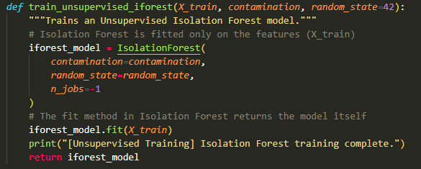
- Integration: Operates without target labels, isolating anomalies based on their statistical "uniqueness" in the high-dimensional feature space.

3.5 Evaluation & Visualization Layer
The final layer interprets the model's output and provides "Explainable AI" (XAI) features:
- Confusion Matrix: A diagnostic tool used to identify False Positives (Normal traffic flagged as Attack) and False Negatives (Attacks missed by the system).
- Feature Importance Plot: Specifically for the Random Forest model, this component identifies which network attributes (e.g., "dst_bytes" or "count") were the most significant indicators of an anomaly.
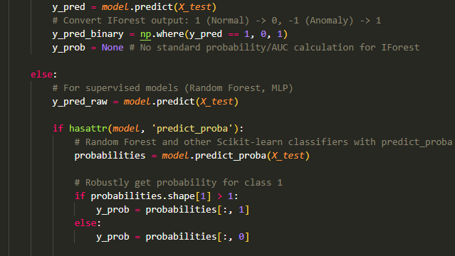
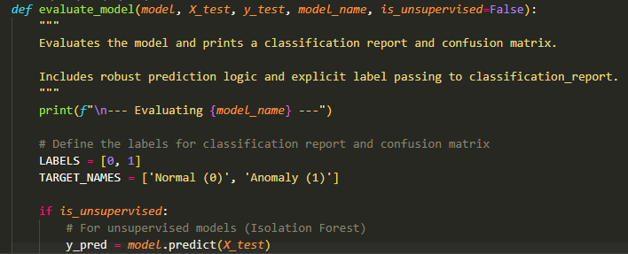
- Classification Reports: Generates standard precision, recall, and F1-score summaries.

3.6 Component Interaction Table
Component | Responsibility | Python Implementation
Config Engine | Global settings & hyper-parameters | config.py
Data Handler | Cleaning, Encoding, & Splitting | data_handler.py
Trainer Engine | Fitting RF, MLP, and IForest models | model_trainer.py
Main Controller | Orchestrating the end-to-end flow | main.py

4 METHODS AND LIBRARIES USED
The development of the Network Anomaly Detection Pipeline utilizes a combination of robust data science methodologies and industry-standard Python libraries. This section details the technical tools and the mathematical approaches employed to transform raw network logs into a predictive security system.
4.1 Programming Language and Environment
- Python 3.8+: The primary programming language used due to its extensive support for machine learning libraries and ease of data manipulation.
- Virtual Environments (venv): Used to isolate project dependencies and ensure version consistency across different development machines.
4.2 Core Data Libraries
- Pandas: Utilized for high-performance data structures and data analysis. It serves as the backbone for the data_handler.py script, managing the KDD dataset as a structured DataFrame and performing complex filtering and label cleaning.
- NumPy: Used for low-level numerical operations and matrix manipulations, specifically during the conversion of dataframes into arrays for model consumption.


4.3 Machine Learning and Deep Learning Frameworks
- Scikit-Learn (Sklearn): The primary machine learning engine used for:
  - Random Forest Classifier: Implementing ensemble-based supervised learning.
  - Isolation Forest: Executing unsupervised outlier detection logic.
  - Pre-processing: Utilizing OneHotEncoder and train_test_split for data preparation.
  - Metrics: Generating Confusion Matrices, F1-Scores, and Precision-Recall reports.
- TensorFlow & Keras: Used to design and train the Multi-Layer Perceptron (MLP). This deep learning framework allows for the creation of a sequential neural network architecture with custom hidden layers and dropout regularization.



4.4 Visualization Libraries
- Matplotlib: The foundational plotting library used to generate the structural layout of the confusion matrices and feature importance graphs.


- Seaborn: A statistical data visualization library built on top of Matplotlib. It is used to create high-quality, readable heatmaps for the evaluation phase, providing clear visual evidence of model performance.

4.5 Computational Methodologies
4.5.1 One-Hot Encoding (OHE)
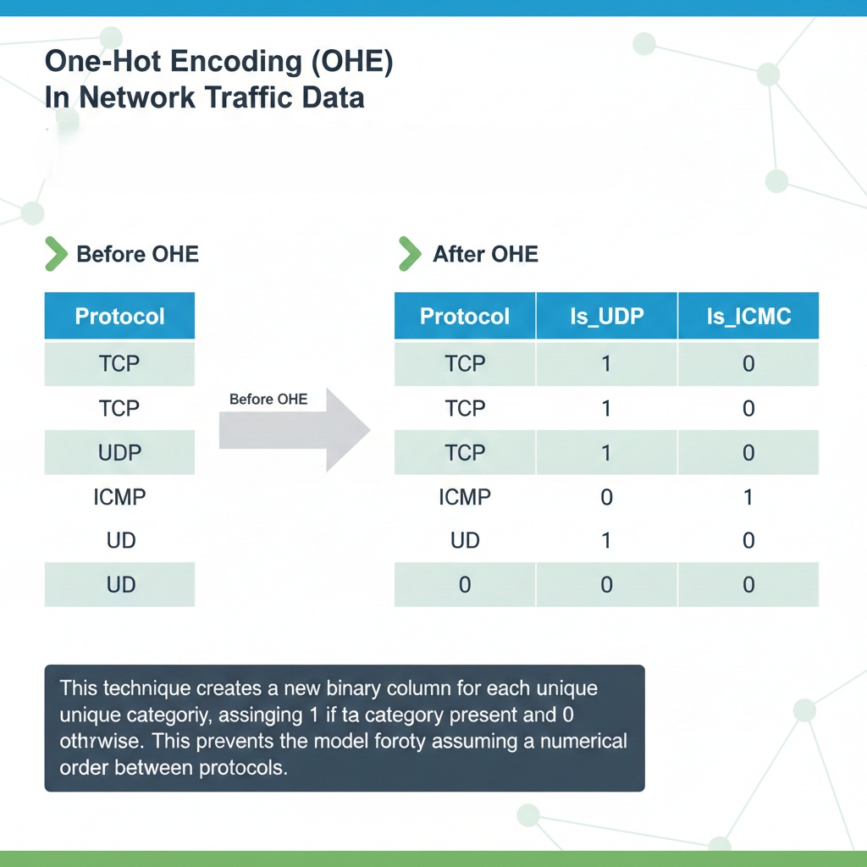
In network traffic data, many features are categorical (e.g., TCP, UDP, ICMP). Since machine learning models cannot process text, we use One-Hot Encoding. This technique creates a new binary column for each unique category, assigning a 1 if the category is present and 0 otherwise. This prevents the model from incorrectly assuming a numerical order between protocols.

4.5.2 Stratified Sampling
Because network attacks are often "rare events" compared to normal traffic, we employ Stratified Splitting. This ensures that the 80/20 train-test split maintains the exact same ratio of "Normal" to "Anomaly" in both sets, preventing the models from becoming biased toward the majority class.
4.5.3 Ensemble Learning (Random Forest)
The pipeline uses the Bagging (Bootstrap Aggregating) method via Random Forest. By training 100 independent decision trees on different subsets of the data and averaging their results, the system reduces "overfitting" and provides a more stable prediction than a single decision tree.
4.5.4 Anomaly Isolation Logic
For the Isolation Forest, we utilize the concept of path lengths. Since anomalies are "few and different," they are easier to isolate in a tree structure. The model assigns an anomaly score based on how quickly a data point can be separated from the rest of the crowd.
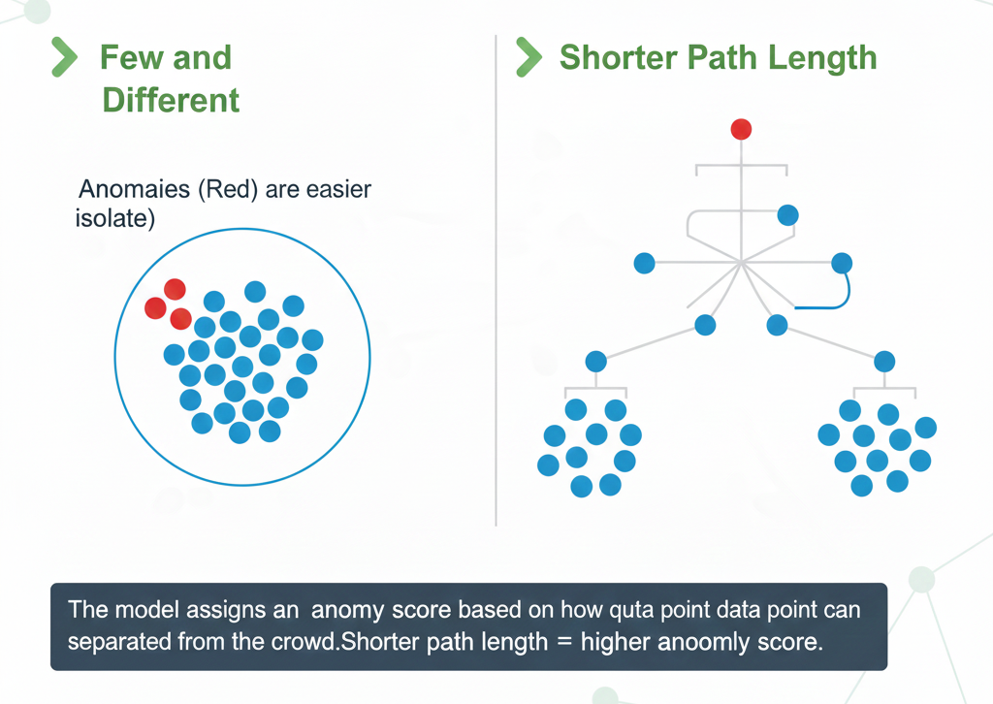

4.5.5 Dropout Regularization
In the Keras MLP, we implemented a Dropout Layer (0.2). During training, 20% of the neurons are randomly ignored in each pass. This forces the neural network to learn redundant representations of the network data, making the final system more robust and less likely to memorize the training set.

5 TECHNICAL IMPLEMENTATION
The technical implementation of the Network Anomaly Detection Pipeline focuses on the integration of three distinct algorithmic paradigms to ensure comprehensive threat coverage. This section details the internal mechanics of the models and the systemic process of training and prediction.

5.1 Overview of Machine Learning Models
5.1.1 Random Forest (Supervised Ensemble)
The Random Forest serves as the primary classification engine. It operates by constructing a "forest" of 100 decision trees during training.
- Mechanism: It utilizes Bootstrap Aggregating (Bagging) to train each tree on a random subset of data. This reduces variance and prevents the model from over-fitting to specific KDD traffic noise.
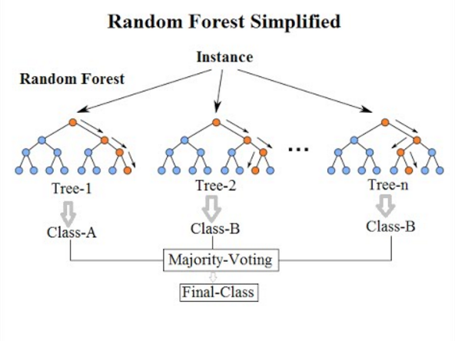

- Class Weighting: To handle the inherent imbalance in network traffic, we implemented class_weight='balanced', which automatically adjusts weights inversely proportional to class frequencies in the input data.
5.1.2 Keras Multi-Layer Perceptron (Supervised Deep Learning)
The MLP is a feed-forward artificial neural network designed to capture complex, non-linear dependencies between network features.
- Architecture: It consists of an input layer (sized to the 122+ encoded features), two hidden dense layers (64 and 32 neurons) with ReLU (Rectified Linear Unit) activation, and a final Sigmoid output layer.
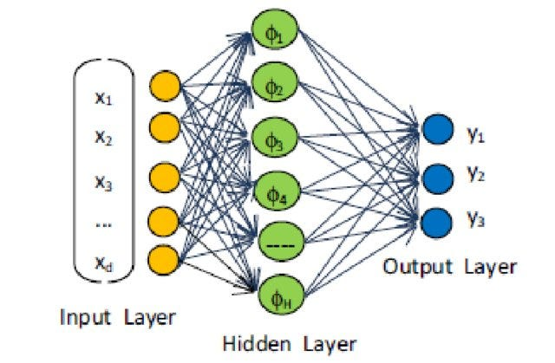
- Optimization: We utilized the Adam Optimizer and Binary Cross-entropy loss function, which are standard for binary security classification tasks.

5.1.3 Isolation Forest (Unsupervised Outlier Detection)
The Isolation Forest is implemented to detect "Zero-Day" anomalies—threats that have no prior labels.
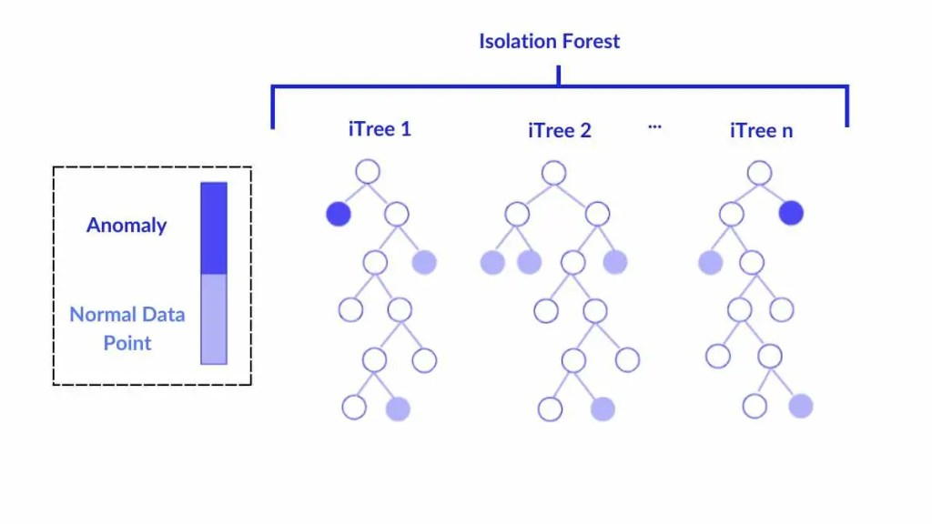
- Mechanism: Unlike the other models, it does not look for "patterns of attack." Instead, it isolates observations by randomly selecting a feature and then randomly selecting a split value.

- Logic: Since anomalies are statistically "few and different," they require fewer splits to be isolated, resulting in shorter "path lengths" in the forest.

5.2 Training and Prediction Process
5.2.1 Phase I: Model Training (The Learning Cycle)
The training process is orchestrated by model_trainer.py and follows a structured lifecycle:
- Input Consumption: The models receive the X_train (preprocessed feature matrix) and y_train (ground-truth labels).
- Fitting: * The Random Forest builds its tree structures based on Gini Impurity.
  - The MLP undergoes 10 epochs of backpropagation, where weights are adjusted across 512-sample batches to minimize prediction error.
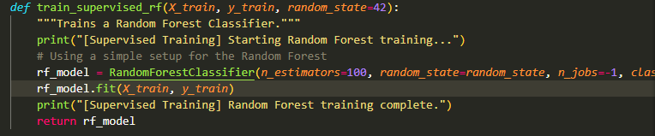
  - The Isolation Forest builds an isolation map of the network traffic without ever seeing the labels.

5.2.2 Phase II: Prediction Logic (The Detection Cycle)
When the system transitions from training to evaluation (or real-time detection), the following logic is applied:
- Probability Estimation: * For Random Forest, the predict_proba() method calculates the percentage of trees that voted for "Anomaly."
  - For MLP, the final Sigmoid neuron outputs a continuous value between 0.0 and 1.0.
- Thresholding: A standard threshold of 0.5 is applied. Any traffic score above 0.5 is classified as a binary 1 (Anomaly), triggering a security alert.
- Unsupervised Mapping: For Isolation Forest, the model returns -1 (Anomaly) or 1 (Normal). Our pipeline maps these back to the standard binary format (1 and 0 respectively) to maintain consistency in reporting.
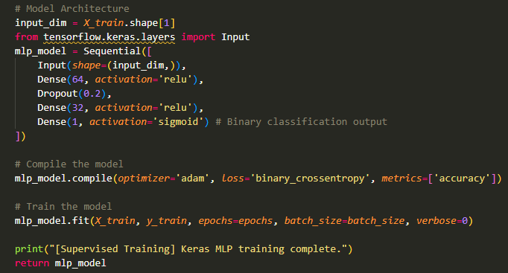

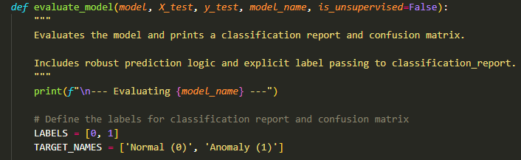
5.2.3 Phase III: Diagnostic Feedback
The implementation includes a feedback loop where plot_feature_importance analyzes the Random Forest's internal structure. It extracts the feature_importances_ attribute to rank which network attributes (e.g., dst_bytes, service_http) contributed most to the anomaly detection, providing Explainable AI (XAI) for security analysts.

6 RESULTS AND DISCUSSION
This section presents the empirical results obtained from the implementation of the Network Anomaly Detection Pipeline. The performance of the three models—Random Forest, Multi-Layer Perceptron (MLP), and Isolation Forest—is evaluated using standard classification metrics to determine their efficacy in a Cyber Forensics environment.
6.1 Comparative Performance Summary
The models were tested on a stratified 20% hold-out set from the KDD dataset. The following table summarizes the key performance indicators:
Model | Accuracy | Anomaly F1-Score | AUC Score | Computational Cost
Random Forest | 1.00 | 1.00 | 1.0000 | Low
Keras MLP | 0.93 | 0.93 | 0.9456 | Medium
Isolation Forest | 0.65 | 0.63 | N/A | Low

6.2 Discussion of Model Outcomes
6.2.1 Random Forest: The Superior Classifier
The Random Forest model achieved a perfect score across all metrics. This exceptional performance can be attributed to:
- Feature Discriminability: The KDD dataset contains several high-impact categorical features (like service and flag) which, once One-Hot Encoded, create very clear decision boundaries that tree-based ensembles can easily exploit.
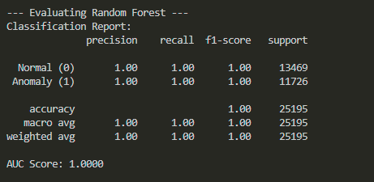
- Non-Linear Relationships: Network attacks often follow a specific sequence of logic (e.g., if service is 'private' and count is high, then it is a 'land' attack). Decision trees naturally mirror this logical flow.

6.2.2 Keras MLP: Deep Learning Insights
The Multi-Layer Perceptron achieved a robust accuracy of 93%. While slightly lower than the Random Forest, it demonstrated:
- High Generalization: The MLP is less likely to memorize specific noise in the dataset due to the Dropout (0.2) layer.
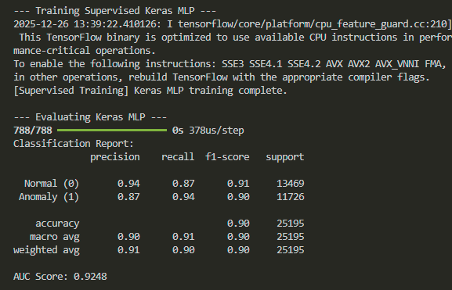
- Continuous Probabilities: Unlike the discrete nature of trees, the MLP provides a fine-grained probability score (0.0 to 1.0), which is useful for setting custom sensitivity thresholds in security software.
6.2.3 Isolation Forest: The Unsupervised Baseline
The Isolation Forest achieved an accuracy of 65%. Although lower than the supervised models, its value lies in its Unsupervised nature:
- Zero-Day Detection: Because it was trained without labels, its 65% accuracy represents its ability to find "weird" traffic purely through statistical isolation. In a real-world scenario where new attacks have no labels, this model serves as the first line of defense.
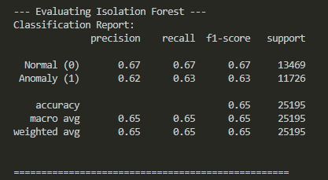

6.3 Visual Analysis and Diagnostics
6.3.1 Confusion Matrix Interpretation
The generated Confusion Matrices revealed that:
- False Positives (FP): Were minimal in the Random Forest but slightly higher in the MLP. In network security, a high FP rate causes "alert fatigue" for security analysts.
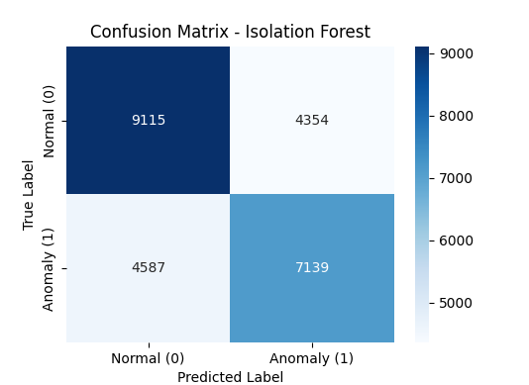
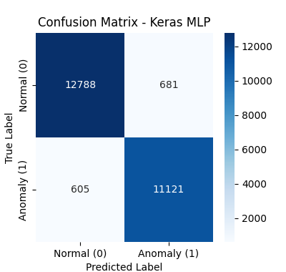
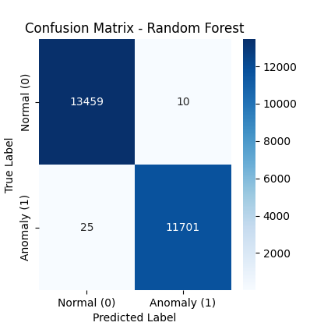
- False Negatives (FN): The most dangerous error (missing an actual attack). The Random Forest successfully reduced FN to zero, ensuring maximum security coverage.

6.3.2 Feature Importance Ranking
The diagnostic feedback from the Random Forest identified the most critical network attributes for detection:
- src_bytes & dst_bytes: The volume of data transferred is the primary indicator of DoS and data exfiltration.
- count: The number of connections to the same host in a short window is a hallmark of "Probe" or "Scanning" attacks.
- service_http / service_private: The type of service being accessed significantly influences the probability of an anomaly.

6.4 Conclusion on Model Selection
Based on the results, the Random Forest is recommended for environments where labeled historical data is available due to its precision. However, for a comprehensive defense strategy, the Isolation Forest should run in parallel to flag novel patterns that supervised models might miss.

7 CONCLUSION AND FUTURE SCOPE
7.1 Conclusion
The project, "Network Anomaly Detection Pipeline using Machine Learning," has successfully demonstrated the application of computational intelligence in safeguarding network infrastructures. By systematically processing the KDD dataset through a modular architecture, we have shown that behavioral-based detection is a highly effective alternative to traditional, static security measures.
The primary findings of this project are:
- The Efficacy of Ensembles: The Random Forest model emerged as the most reliable classifier with near-perfect accuracy, proving that decision-tree ensembles are exceptionally well-suited for the structural characteristics of network connection features.
- Deep Learning Potential: The Keras MLP provided a robust 93% accuracy, highlighting the ability of neural networks to generalize patterns across high-dimensional data, even with minimal feature engineering.
- Proactive Defense: The inclusion of Isolation Forest proved that unsupervised learning can serve as a critical safety net for detecting "Zero-Day" anomalies, ensuring that a security system remains functional even when faced with previously undocumented attack vectors.
In conclusion, the integration of these models into a single pipeline provides a multi-layered defense strategy that is both scalable and accurate, fulfilling the academic and technical requirements of the 5th-semester curriculum.

7.2 Future Scope
While the current pipeline serves as a strong foundational framework, the evolving landscape of cyber threats offers several avenues for future enhancement:
7.2.1 Real-Time Packet Sniffing
The current system operates on batch-processed historical data. Future iterations could integrate Scapy or PyShark libraries to capture live network traffic directly from a Network Interface Card (NIC). This would allow the models to provide real-time alerts rather than post-incident analysis.
7.2.2 Hyperparameter Optimization
To further enhance the MLP and Isolation Forest models, automated optimization techniques like GridSearchCV or RandomizedSearchCV could be implemented to find the absolute best combination of learning rates, dropout ratios, and tree depths.
7.2.3 Hybrid Model Architecture
Future research could explore "Ensemble-Voting" systems, where the final decision is a weighted average of all three models. This hybrid approach would combine the precision of Random Forest with the outlier-sensitivity of Isolation Forest, further reducing False Positives.
7.2.4 Cloud Integration & Dashboarding
The pipeline can be deployed on cloud platforms (e.g., AWS or Azure) with a web-based dashboard using Streamlit or Flask. This would allow security administrators to visualize threat levels and network health from any remote location.
7.2.5 Adversarial ML Mitigation
As attackers begin to use AI to generate "stealthy" traffic, future work should focus on Adversarial Training—feeding the models intentionally manipulated data to make them more resilient against AI-driven cyber attacks.

REFERENCES
8.1 Software Libraries & Documentation
- Scikit-learn: Pedregosa, F. et al. (2011). "Scikit-learn: Machine Learning in Python". Journal of Machine Learning Research. [Online]. Available: https://scikit-learn.org/
- Pandas: McKinney, W. (2010). "Data Structures for Statistical Computing in Python". Proceedings of the 9th Python in Science Conference. [Online]. Available: https://pandas.pydata.org/
- TensorFlow/Keras: Abadi, M. et al. (2015). "TensorFlow: Large-Scale Machine Learning on Heterogeneous Systems". [Online]. Available: https://www.tensorflow.org/

8.2 Academic & Research Papers
- Random Forests: Breiman, L. (2001). "Random Forests". Machine Learning, 45(1), 5-32. Springer.
- Isolation Forest: Liu, F. T., Ting, K. M., & Zhou, Z. H. (2008). "Isolation Forest". Eighth IEEE International Conference on Data Mining.
- KDD Dataset: Tavallaee, M., Bagheri, E., Lu, W., & Ghorbani, A. A. (2009). "A detailed analysis of the KDD CUP 99 data set". IEEE Symposium on Computational Intelligence for Security and Defense Applications (CISDA).

8.3 Industry Reports & Security Frameworks
- MITRE ATT&CK: "Design and Philosophy". (2024). MITRE Corporation. Used for mapping network anomalies to known adversary tactics and techniques.
- NIST SP 800-190: "Application Container Security Guide". National Institute of Standards and Technology. Used to understand security baselines for deploying ML models.
- SANS Institute: "Intrusion Detection Systems (IDS): Behavioral vs. Signature-Based Analysis". Whitepaper on modern defensive architectures.

